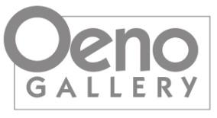

oenogallery.com
info@oenogallery.com
613.393.2216

claudia jean mccabe
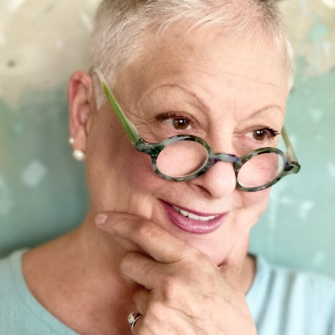
Montreal-born claudia jean mccabe is a recognized Canadian painter, graphic designer, teacher, creator of musings…. and a dreamer.
Over the course of her artistic career, she has participated in numerous solo, featured and group exhibitions at both provincial and national levels. An award-winning artist and an elected member of the Society of Canadian Artists, McCabe’s paintings are held in private, corporate and government collections worldwide.
“For reasons, beyond seasons, I paint. Colour, form, freedom, harmony, asymmetry – all continue to awaken my soul, fuel my passion, and draw me ever closer to creativity’s infinite mysteries. Painting keeps this artist ever curious, ever searching, ever grateful, and joyfully alive.”
— claudia jean mccabe

Education

1989-90 Graphic Design, Honours, George Brown College, Toronto, ON
2012 Bachelor of Fine Arts Degree, Major in Sculpture & Installation, OCAD University, Toronto, ON

Solo/Group Exhibitions

1991 Solo Exhibition, Cibo’s Gallery, Toronto, ON
1992 Joint Exhibition with Brian Atyeo, Harbour Gallery, Oakville, ON
1993 Solo Exhibition, Buckingham Fine Arts, Uxbridge, ON
1999-05 Group/Featured Exhibitions, Ingram Gallery, Toronto, ON
2007 Solo Exhibition, Sandra Whitton Gallery, Kingston, ON
2020 Solo Exhibition, Sybil Frank Gallery, Wellington, ON
2010-20 Group Exhibitions, Koyman Galleries, Ottawa, ON
2013-20 Group/Featured Exhibitions, Gallery 121, Belleville, ON
2010-25 Arts in the County, Annual Juried Exhibition, Prince Edward County, ON

Teaching / Workshops

1994-96 Teacher, Fred Varley Art Gallery, Unionville, ON
1996-06 Founder & Teacher, School House Group of Artists, Lemonville, ON
2006-09 Maggiolly Art, Orangeville, ON
2003 Durham Group of Artists, Toronto, ON
2006-20 Amherst Island, ON
2000-2020 Loyalist College, Belleville, ON
1999-04 St Lawrence College, Brockville, ON
2005 East Ontario Art Association
2014-20 Open Studio, Belleville, ON

Publications / Projects

2004 MAGAZINART, “L’irrepresible Claudia Jean McCabe “
1991-98 Unionville Economist & Sun
1991-12 Project graphic designer, Arts and Letters Club of Toronto
2004 Logo design, The Society of Canadian Artists, (Watershed feature, County Living Magazine feature)
2010 Self-published book, “Musings & Fantasy Paintings”
2012 Chair, 21st anniversary of Art in the County’s annual juried exhibition and sale
1992-15 Juror and guest speaker, art exhibitions and special events
2016 Mrs. Toddle bottom’s Christmas story, recorded on CD

Memberships

1999 Elected to Society of Canadian Artists
1991-12 Arts and Letters Club of Toronto
2010-25 Prince Edward County Arts Council

Collaborations

2006-10 ‘Beauty in Bloom’ annual calendar, Pineridge Art and Hallmark Canada
2009-12 ‘Pieces d’Art’ greeting cards & licensing of painting reproductions to ’The Great Big Canvas Company’, Looking Good Licensing, USA
2011 Posie Jones brand Introduction, New York City

Government Collections

1989 Canadian Institute of International Affairs (CIIA), gift of framed, limited-edition work on paper from Canada to select embassies & consulates (Argentina, Australia, Bermuda, Brazil, Chile, Great Britian, New Zealand, People’s Republic of China, South Africa, Switzerland)

Corporate Collections

Block Drug Company (Canada) Ltd.
CamVec Corporation
Canadian Imperial Bank of Commerce
Canadian Polystyrene Association
Canexa Corporation Inc
COMPASS Performance Strategies Inc.
Etobicoke Board of Education
K.F. Prueter Collection of Canadian Art
Kayser Mson Ball & Lewis
Leggatt Motors Inc.
Manitoulin Transport
Oakville General Hospital
RBA Advertising (Canada) Ltd.
Southlake Regional Health Centre
Standard Broadcast Sales
University of Toronto

